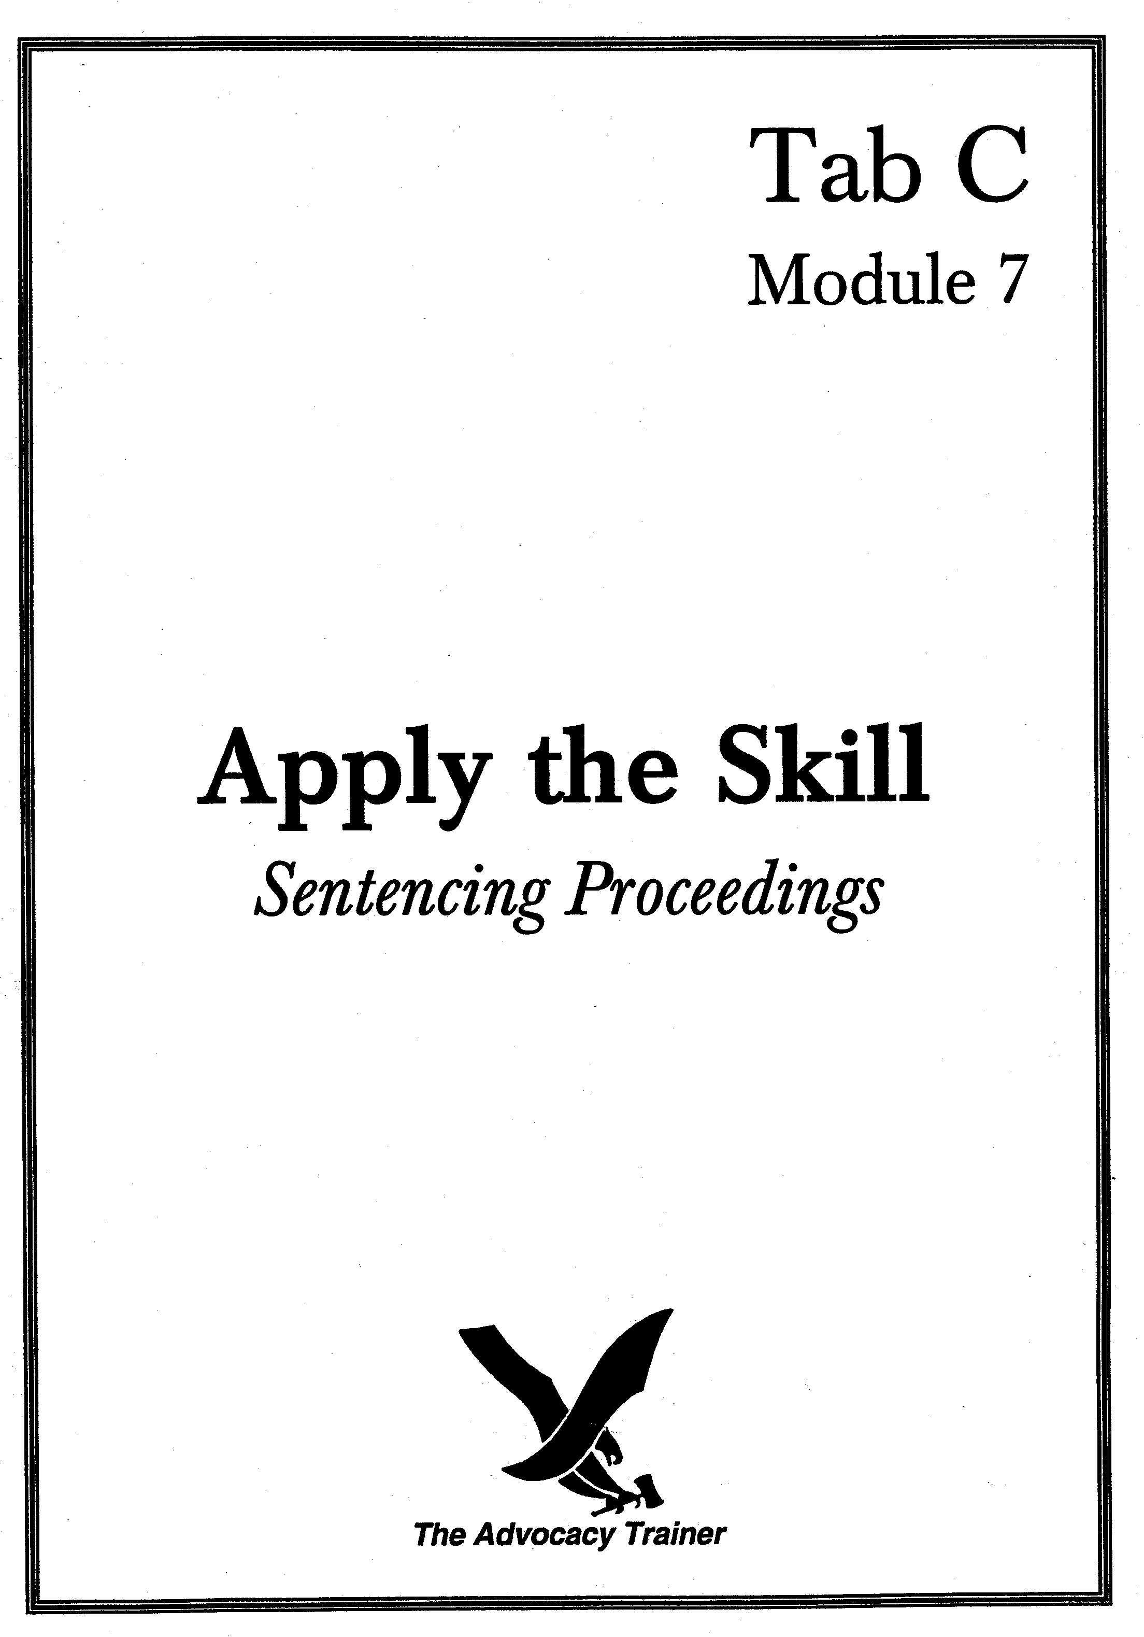
sentencing proceedings
company commander - direct examination
supervisor’s guide

 skill overview.

Goals. Between 1989 and 1996, nearly 13,500 general and special courts-martial were prosecuted in the Army with a conviction rate of over 92%. This means the vast majority of trials reach the sentencing phase. While trial counsel all too often take the position that sentencing is a matter for the defense, in reality the Rules for Courts-Martial provide the government with powerful ammunition to present a variety of evidence for consideration by the military judge or panel in crafting an appropriate sentence. Chiefs of justice must ensure that trial counsel do not abdicate their responsibilities in this regard.

The company commander is a key component of the government’s sentencing case. The commander is often in the best position to know the accused and gauge the effect of the misconduct on the unit. Trial counsel should remember that, generally, panel members and judges are most concerned with the effect of the accused’s crimes on the health and welfare of soldiers, on good order and discipline within the unit, on the ability of the unit to perform its mission, and whether the accused has any potential for rehabilitation. It is usually the commander who can best speak to these issues.

Training overview. This training module requires at least three participants: one supervisor, one trial counsel, and one company commander; a fourth person could play the defense counsel. The training is divided into four steps: (1) an instruction period; (2) counsel preparation time; (3) a practical exercise and critique; and (4) a sample solution review. It takes one hour to complete.

 the law.

Procedure. RCM 1001(a)(1)(A) lists five different categories of evidence that the prosecution may present to the fact-finder in determining an appropriate sentence. RCM 1001(b) discusses each category separately. Effective use of RCM 1001(b) necessarily includes introduction of personal and service data of the accused, evidence of any prior convictions, evidence reflecting aggravating circumstances, and evidence of the accused’s rehabilitative potential. This module focuses on the two broadest categories: mission impact evidence and evidence of rehabilitative potential.

Evidence in aggravation. RCM 1001(b)(4).
- A company commander may be an excellent government witness in aggravation because he or she may be able to testify about circumstances “directly relating to or resulting from the offenses of which the accused has been found guilty.” RCM 1001(b)(4) (discussion).
- Aggravation evidence may include the impact of the accused’s offenses on the mission, discipline or efficiency of the command. The key to so-called “unit-impact” evidence is the ability of trial counsel to link the offense(s) for which the accused has been convicted and their impact on the unit or mission. Mere relevance of the purported aggravating circumstance is insufficient for admission of evidence under this rule. Rather, the effect on unit readiness, morale and discipline must directly stem from the offense.
- Some examples of unit impact evidence could include:
- accused’s loss of security clearance required removal from flightline which affected crew integrity;
- co-workers had to perform extra duty because of accused’s AWOL;
- after series of barracks larcenies, soldiers were required to perform 24 hour hall guard duty until perpetrator was caught;
- work had to be delegated to other units to avoid contact between a sex offender and his victim;
- because accused was the only member of the unit capable or trained to perform a critical task [e.g., Tagalog linguist, communications specialist, physician’s assistant, boom crane operator] unit could not deploy or mission had to be scrubbed;
- accused’s hate crimes resulted in order to remove all paraphernalia from walls of barracks rooms, to include innocuous and noninflammatory pennants, posters, pictures and photographs;
- senior enlisted comes up hot on urine test. Because he is well liked and respected in the unit, junior subordinates conclude there must have been some mistake made in collection or testing. Result is loss of confidence in the Army’s drug testing program;
- turnaround time for avionics repair in division aviation maintenance section goes from two to seven days due to hostile work environment caused by section leader’s fraternization, harassment and pattern of sexual misconduct with subordinates - aircraft redlined; and
- accused intentionally fails to rescue soldier, who later dies, after causing vehicle accident during field training exercises. Conduct causes brigade members to lose trust and confidence in one another to watch each other’s backs.

Evidence of rehabilitative potential. RCM 1001(b)(5).
- Rather than considered as a matter in aggravation, lack of rehabilitative potential is a separate factor for consideration in determining an appropriate sentence. “Rehabilitative potential” refers to the accused’s potential to be restored to a useful and constructive place in society, not potential for continued military service.
- Evidence of the accused’s rehabilitative potential must be introduced through opinion testimony; the quality of that opinion necessarily depends on the quality of the foundation, and that is the focus of this module. Counsel must also know that opinion evidence of rehabilitative potential may not be based solely on the severity of the offense. Further, the scope of the evidence is limited to whether the accused has rehabilitative potential, and to the magnitude or quality of such potential, and not testimony regarding the appropriateness of a punitive discharge.
- Foundation:
- Sufficient knowledge of the accused to formulate a rationally based opinion;
- not based on seriousness of offenses, what’s best for the service, or administrative consequences of conviction; and
- scope is limited to whether accused has rehabilitative potential, as opposed to potential for future service.

 Practice Pointers.
- If you determine that rehabilitative potential evidence is essential to make your sentencing case, scrupulously avoid questions referring to discharge, separation from service, lack of potential for continued service.

- If introducing RCM 1001(b)(4) evidence, be able to articulate just how the accused’s misconduct has directly affected unit morale, welfare, readiness or discipline.

- Regardless of the use to which put, there is a common thread running through any presentation involving the commander - What does the commander know? How does the commander know it? What is the impact?

 skill drills.

 Unit and Mission Impact.

While this drill has the secondary benefit of practicing interview skills, its primary purpose is to force counsel to elicit information about the effect of the accused’s conduct on the command, the unit, and the mission from a real witness, a sitting company commander. Because counsel are approaching the exercise “in the dark,” they cannot help but ask open-ended questions, which is the approach a trial counsel’s sentencing presentation should follow. In this exercise, you will play the part of the military judge. No student handouts are necessary. Give your counsel the following fact pattern and have them develop a direct examination of the company commander involving unit impact evidence.

We recommend you use a real company commander to act as the witness. This will provide trial counsel with the opportunity to improve their interview skills as well as give the commander the chance to feel what it’s like to undergo a direct examination. Counsel should ask questions designed to elicit testimony describing the impact of the accused’s conduct, which counsel can later refer to during argument.

Scenario. Corporal John Smith has been convicted of being drunk on duty and barracks larceny. He is the only fuel truck driver for the Division Support Command.

 Rehabilitative Potential.

A primary purpose of this drill is ensure that trial counsel understand the rather significant limitations imposed by the courts and MCM on the scope and admissibility of rehabilitative potential testimony. You should lead a discussion and focus on whether this type of evidence is ever beneficial and, if so, in what forum and under what circumstances. Once you decide the issues have been adequately addressed, you should give counsel the following fact pattern and have them conduct a practice direct examination of the company commander. No student handouts are necessary.

Scenario. Staff Sergeant Johnson Pepper is the NCOIC of the battalion motor park. He has been convicted of embezzling over $70,000 worth of supplies over a two year period. Except for this incident, he has an otherwise good record, although he has been counseled a number of times on grooming, physical appearance and organizational skills. His company commander knows Pepper from monthly walk-throughs and reports from the first sergeant.

 references.

Lauren Hemperley, Looking Beyond the Verdict: An Examination of Prosecution Sentencing Evidence, 39 A.F. L. Rev. 185 (1996).

Carol DiBattiste, The Prosecution Sentencing Case, 27 A.F. L. Rev. 203 (1987).

Denise K. Vowell, To Determine an Appropriate Sentence: Sentencing in the Military Justice System, 114 Mil. L. Rev. 87 (1986).

Joseph A. Russelberg, Sentencing Arguments, A View from the Bench, Army Law., Mar. 1986 at 50.
ENCLOSURES
Counsel Handout
Sample Solution
SENTENCING PROCEEDINGS
COMPANY COMMANDER - DIRECT EXAMINATION
COUNSEL HANDOUT

 TRAINING OVERVIEW.

Introduction. We will conduct trial advocacy training in the courtroom on ____________________, from ______to______hours. The training will focus on unit-impact and rehabilitative potential evidence introduced through the company commander.

Preparation. Bring your MCM to the training. Review basic techniques of direct examination. Review RCM 1001.

 keys to success.

Know the elements of a foundation to admit rehabilitative potential evidence.

Be able to articulate a connection between the accused’s offenses and an impact on the unit.

references for further study.

Lauren Hemperley, Looking Beyond the Verdict: An Examination of Prosecution Sentencing Evidence, 39 A.F. L. Rev. 185 (1996).

Carol DiBattiste, The Prosecution Sentencing Case, 27 A.F. L. Rev. 203 (1987).

Denise K. Vowell, To Determine an Appropriate Sentence: Sentencing in the Military Justice System, 114 Mil. L. Rev. 87 (1986).

Joseph A. Russelberg, Sentencing Arguments, A View from the Bench, Army Law., Mar. 1986 at 50.
Company Commander - Direct Examination

Sample Solutions



Mission / Unit Impact

Q. CPT Apple, you are the accused’s company commander?
A. Yes, I am, for the last eight months anyway.

Q. You’re aware that the accused has been convicted of being drunk on duty and stealing money and stereo equipment from his fellow soldiers?
A. Yes.

Q. CPT Apple, have these offenses had an impact on your unit?
A. Yes, they’ve had a significant impact.

Q. CPT Apple, what impact has the accused’s offenses had on your unit?
A. Well, for one thing, CPL Smith was my only fuel truck driver. Since this happened, he has been pulled from duty; I certainly can’t trust him behind the wheel now. So the brigade had to cancel three field training exercises because we couldn’t support their fuel needs. I was able to get a loaner from 3d brigade to cover two other missions, but they have their own exercises which have to take priority.

Q. Why can’t you just put in for a new driver?
A. Well, as I understand it, the replacement detachment won’t let me do anything because Smith is still slotted in that position on my TOE. Until he is off my manning roster, I can’t submit a request for a personnel fill. I’ll tell you one thing, something has to happen soon because these commanders are starting to get concerned over their dropping readiness rates.

Q. Anything else?
A. Yes. Before Smith’s crimes, the members in my unit all trusted each other so much so that they used to leave their doors unlocked. People would just come and go - camaraderie and morale were sky high. Because Smith stole from his own, now all my soldiers lock the doors when they leave, even when they are just going down the hall to the telephone room. This was not anything I ordered them to do, mind you. This was all on their own initiative. I think it is going to be a long time before we ever achieve the same degree of reliance and trust the unit shared before Smith’s convictions.

Rehabilitative Potential

Q. CPT Jones, you are the accused’s company commander?
A. Yes. I’ve been his commander for the last 22 months.

Q. How well do you know him?
A. I see him monthly when I inspect the motor pool. We’ve also been on three deployments the last 14 months and we have monthly training exercises. In addition, I get weekly reports from the first sergeant on his duty performance. We also belong to the same church group and both volunteer as third base coaches for the Fort Knight Little League. So I would say I know him as well as anybody.

Q. What are his duties?
A. He is the NCOIC of the battalion motor park. He supervises six mechanics.

Q. CPT Jones, you’re aware he has been convicted of larceny and fraud. Did you ever talk to him about these offenses?
A. Yes. I got the impression he wasn’t very remorseful and felt he stopped only because he got caught.

DC. Objection, calls for speculation.

MJ. Sustained.

Q. CPT Jones, if I define rehabilitative potential as the ability to learn from one’s mistakes and correct one’s behavior, do you have an opinion as to this accused’s potential to be restored to a useful and constructive place in society?

DC. Objection. RCM 1001(b)(5) provides the panel members with more than an adequate definition of rehabilitative potential, your honor. The trial counsel is trying to circumvent the will of the President and redefine the concept by trying to add new components.

TC. I’ll rephrase the question, your honor. CPT Jones, would you agree that an ability to learn from one’s mistakes and correct one’s behavior is essential in order for a person to be rehabilitated?
A. Yes.

Q. CPT Jones, do you have an opinion as to this accused’s rehabilitative potential?
A. Yes.

Q. What is that opinion?
A. In my opinion, the accused has no rehabilitative potential.

Q. Why is that?

DC. Objection, your honor. As I am sure counsel is aware, RCM 1001(b)(5) severely limits the scope of this witness’s testimony. This witness is limited to simply offering his opinion regarding my client’s rehabilitative potential to be restored to a useful and constructive place in society and not the reason therefore. That is why I questioned the value of his testimony in the first place.

MJ. Objection sustained. Counsel, I believe you are finished with this witness.

TC Thank you, your honor. No further questions.

“There is no more persuasive evidence available to a military tribunal than the testimony of the accused’s immediate commanding officer.” United States v. Randolph, 20 M.J. 850, 852 (A.C.M.R. 1985).
RCM 1001(b)(1)(A) provides that the trial counsel ordinarily presents matter in the following sequence: (i) service data relating to the accused taken from the top of the charge sheet; (ii) personal data of the accused and the character of the accused’s prior service as reflected in the personnel records; (iii) evidence of prior convictions; (iv) evidence of aggravation, and (v) evidence of rehabilitative potential.
Major Lauren K. Hemperley, Looking Beyond the Verdict: An Examination of Prosecution Sentencing Evidence, 39 A.F. L. Rev. 185 (1996).
This limitation may also apply to the defense. As such, trial counsel should object to testimony to the effect that the accused “could rehabilitate himself and continue to serve and contribute to the United States Army.” See, e.g., United States v. Ramos, 42 M.J. 392, 396 (1995).

